### Data Challenge

Author: Vinay Maruri

#### Executive Summary

* Total Sales for this business declined 22.7% from 2014 to 2015.
* There are large differences in total sales across regions.
* There is a significant spike in sales volume in December of every year.
* There is a positive trend in average dollar amount of each transaction.
* Customer quality is increasing, as average transaction size by join year is increasing.

#### Condition of Business

The first transaction this business registered was on January 4th, 1999. The business is 19 years old (as of 2018). The dataset covers transactions that occurred in this business from January 2013 to May 2016.

Based on transactions that occurred in this dataset, it appears that the business peaked in 2014. Figure 2 shows that 2014 was the best year for the company, as sales were at its highest, and then declined 22.7% year over year for 2015. It appears that there are a series of days or months in 2014 that contributed to high sales numbers that year. Figure 1 shows that there was a significant rise in daily sales volume that is not indicative of typical sales numbers for this business, as similar periods in 2013 and 2015 do not have the same daily sales volume. It is very likely that they ran an especially successful promotion to their customers that contributed to this rise, but I cannot confirm this suspicion since I have no additional information to support it. For 2016, there is likely to be a small increase in total sales, as the first 4 months of transactions are running slightly ahead of the first 4 months of 2015.

Overall, the business appears to be in a sideways trend and has deteriorated overall from 2014.

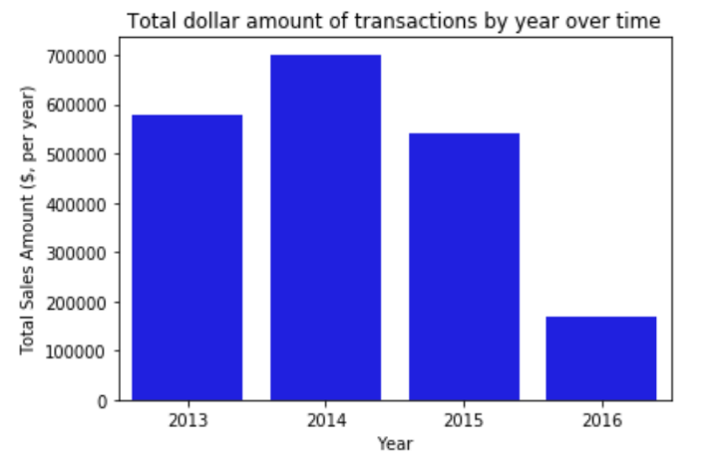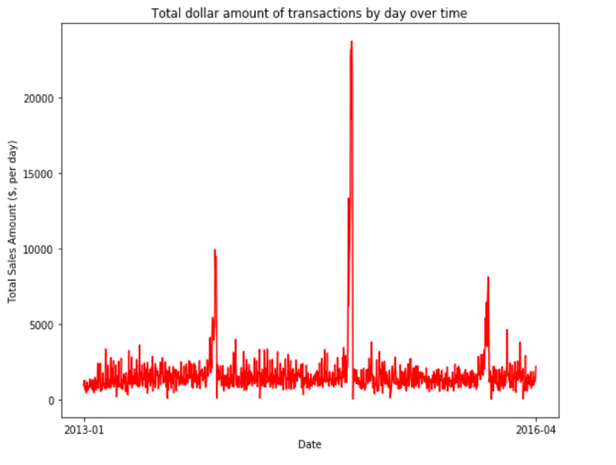

**Figure 2**

**Figure 1**

#### Regional Analysis

This business has 21 regions where transactions were made. As figure 3 shows, average transaction amounts vary by region, as there are regions like R with an average transaction size of $22.16, and regions like S with an average transaction size of $45.51. Furthermore, these regional differences continue when analyzing total sales numbers. Regions like B and C consistently have the largest sales numbers, while Regions R and U are consistently the worst in terms of total sales across the dataset. An example of this phenomena is shown for 2015 in figure 4. This can be explained by the fact that Regions B and C have the largest number of transactions consistently across the dataset, while Regions R and U have the smallest number of transactions consistently across the dataset.

Overall, there are regional disparities in terms of average transaction size, total sales amount, and total number of transactions per year.

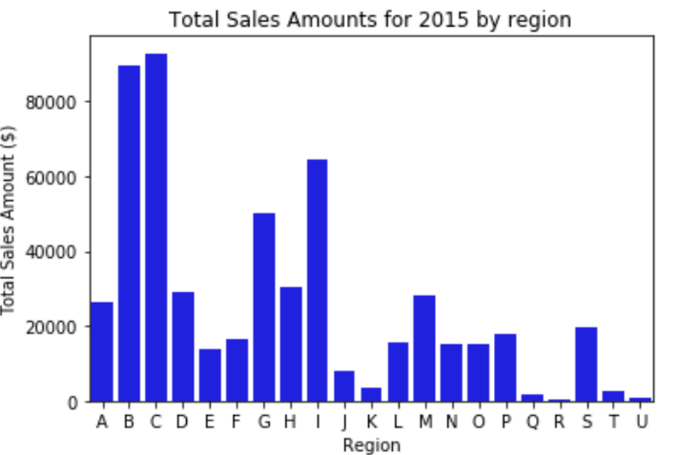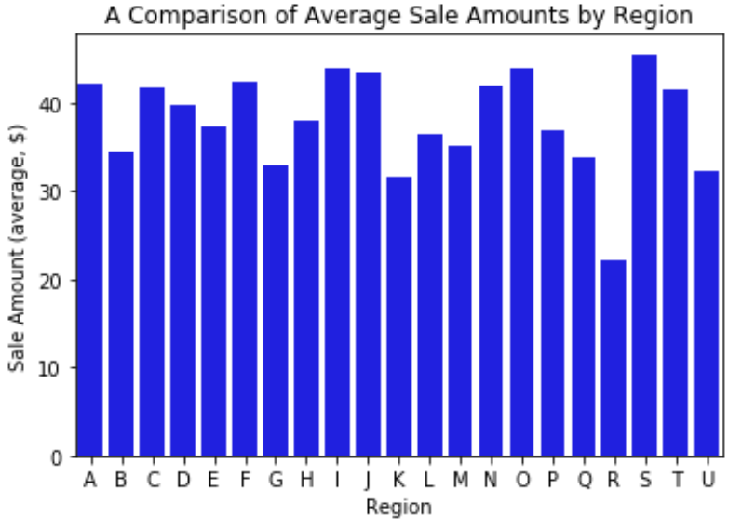

**Figure 3**

**Figure 4**

#### Seasonality

There is one interesting trend regarding seasonality. Throughout the year, sales fluctuate in a relatively minor way. However, as figures 5 and 6 show, in December of every year in the dataset, total sales increase significantly, sometimes quadrupling total November sales. In fact, a large percentage of the sales decline from 2014 to 2015 can be attributed to significantly lower December 2015 sales compared to December 2014 sales.

Overall, there is one trend in seasonality. There is a significant increase in December sales compared to other months of the year, which are relatively constant, fluctuating only modestly.

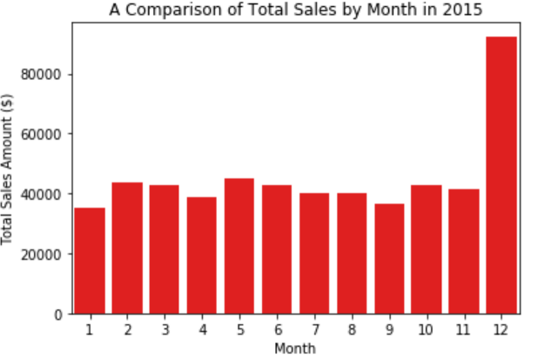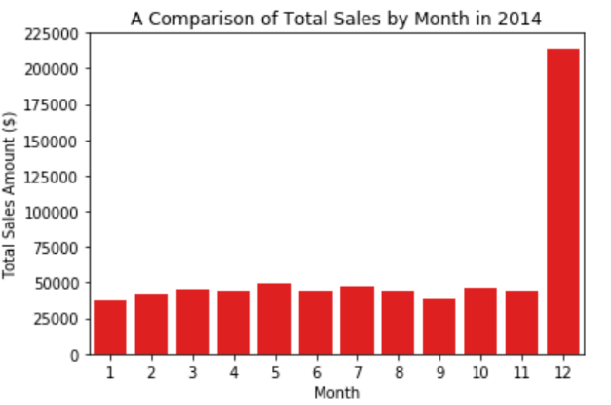

**Figure 6**

**Figure 5**

#### Customer Quality

Given that the company is 19 years old, and is a mature business, I assumed that new customer growth would not be robust. This assumption was confirmed as my analysis shows that the number of new customers increased sharply from 2012 to 2013, and then from 2013 onwards has declined back to 2012 levels. Despite this, as figure 7 shows, average transaction size by join year has increased overall from 1999 to 2016 with some minor fluctuations. With regards to customer quality, the decline in the number of new customers has been offset by the continuing increase in average transaction size by join year, showing that new customers to the platform are spending more.

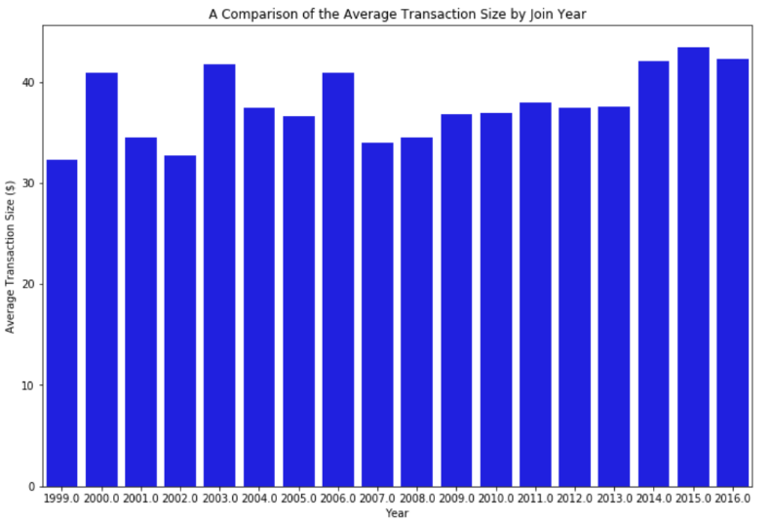Overall, customer quality is getting better over time, as newer users are spending more on average per transaction.

**Figure 7**

#### Analysis

Based on the customer sales data, this business appears to be a semi-seasonal, mature company with stagnating sales. First, there are consistently higher sales for this business in December compared to other months of the year. This should reduce the value of the business overall, since most of this company’s sales are tied to December holiday spending by consumers which is heavily reliant on fluctuating economic conditions. If the economy is doing poorly, then this business will suffer a significant loss in sales as consumers spend less over the holiday season. Second, while customer quality is getting better over time, there are less of them spending money in this business. New customer growth has declined to a low, but stable level. Total sales have declined from their peak, and 2016 does not look like it will be a significantly better year for the company. The business has deteriorated significantly since 2014. Combined with the significant regional differences in sales, this business could be operating at a loss in large sections of its operating regions. For an investment team, this business does not seem to be an attractive investment, as this business does not seem to be growing and could be loss-making. For this business, my findings could be the catalyst for changes in strategy, refocusing on high and moderate revenue regions, given that customer quality is increasing, while shutting down low revenue and customer regions to improve the profitability of this business.